1. OS command injection, simple case 1
2. Blind OS command injection with time delays 1
3. Blind OS command injection with output redirection 2
4. Blind OS command injection with out-of-band interaction 2
5. Blind OS command injection with out-of-band data exfiltration 3

OS command injection, simple case
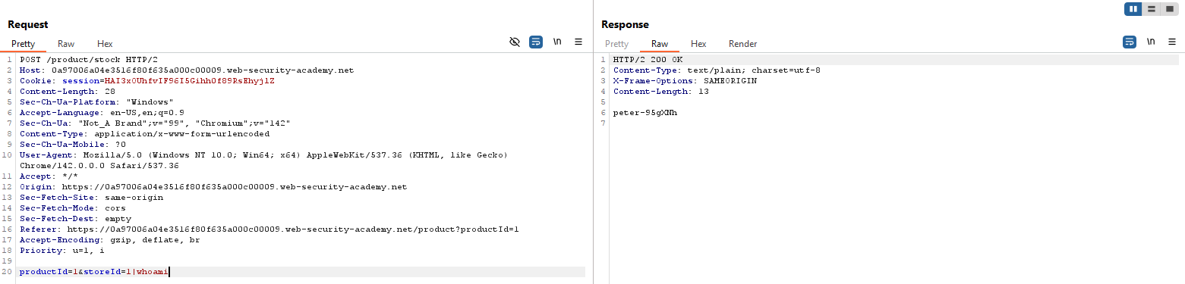

Blind OS command injection with time delays
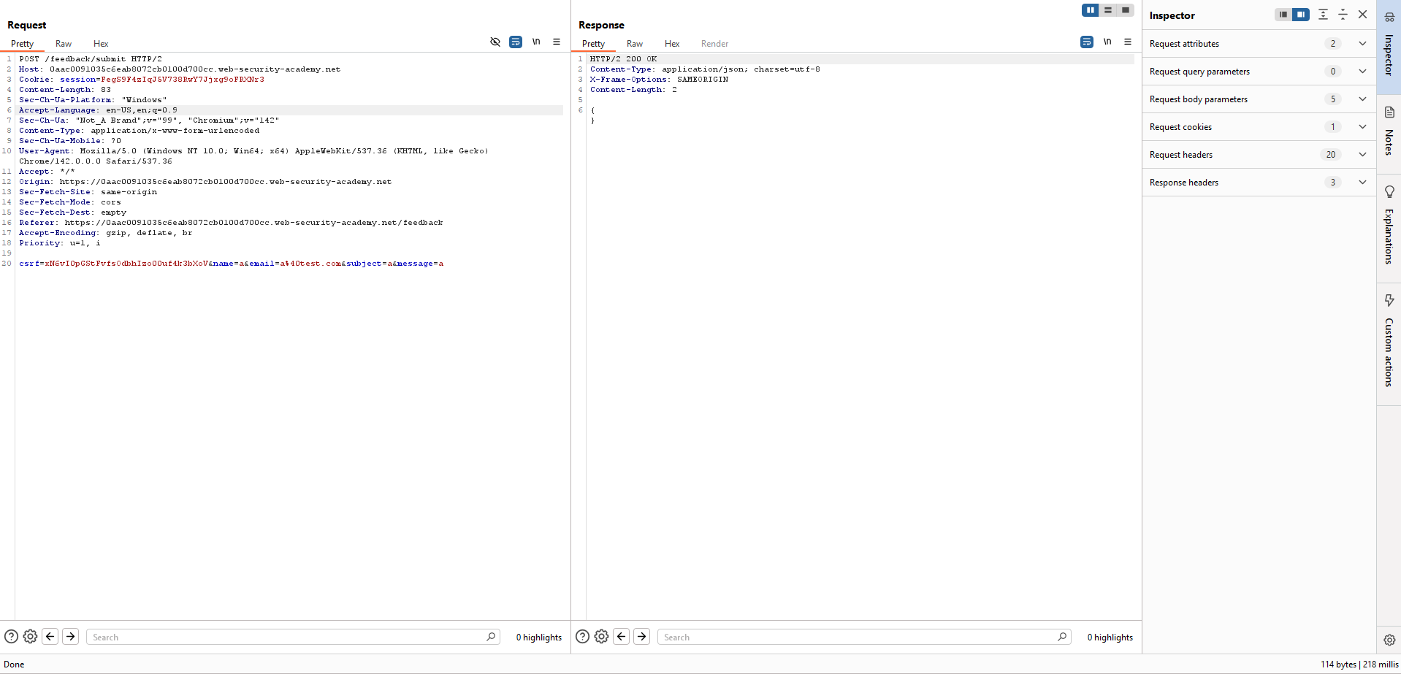
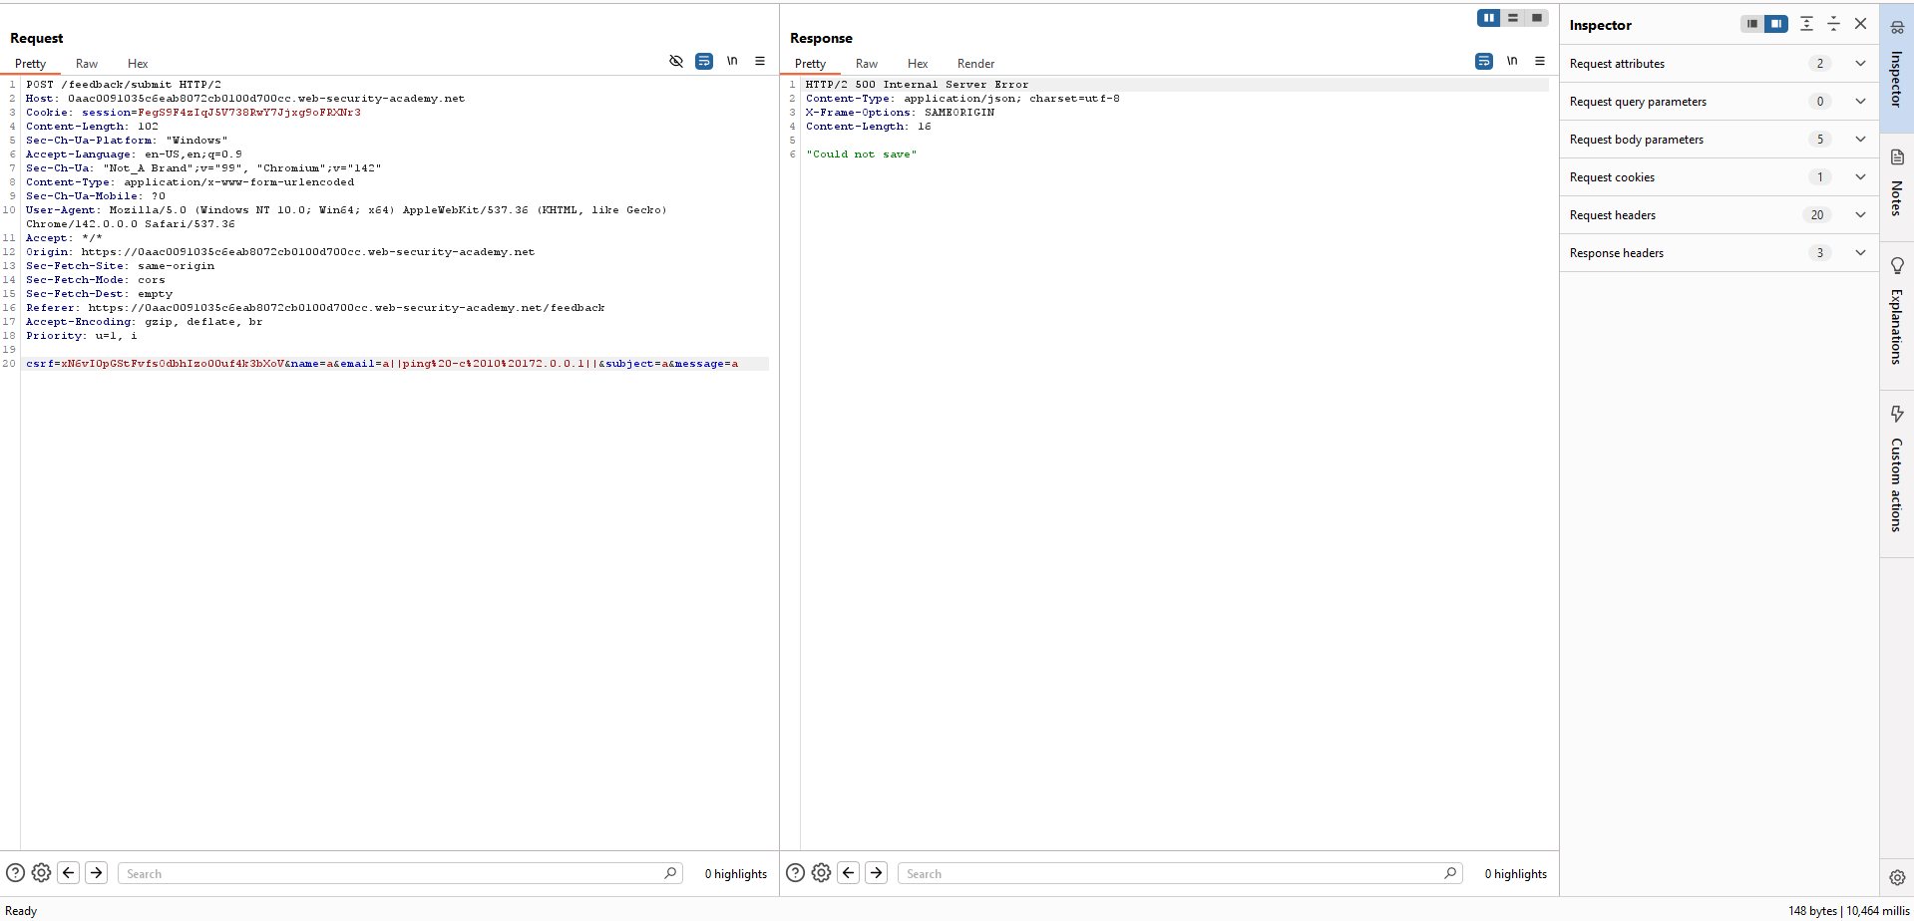

Blind OS command injection with output redirection
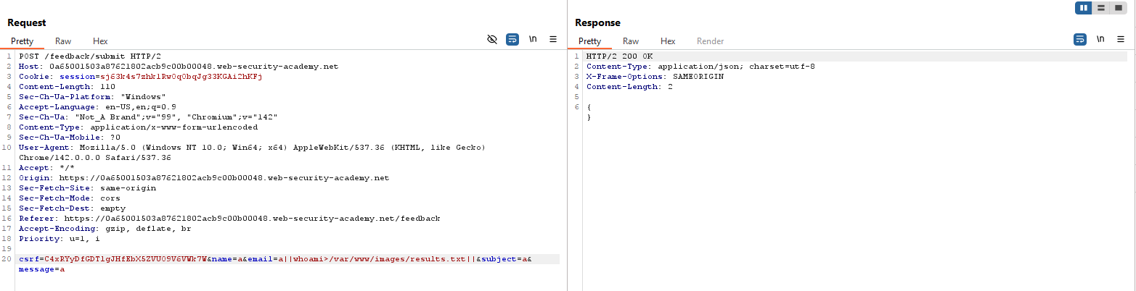
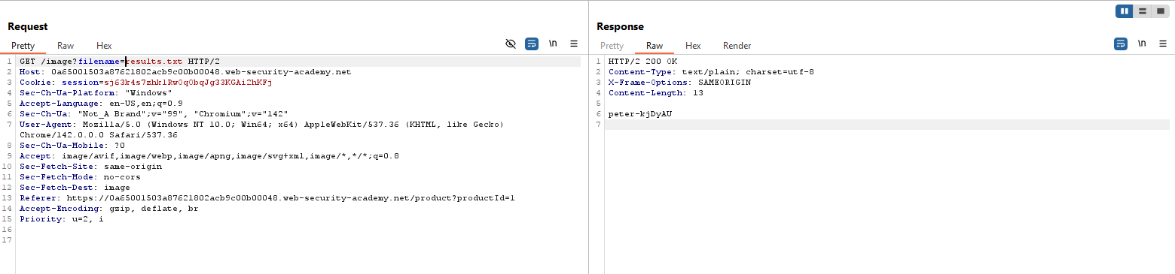

Blind OS command injection with out-of-band interaction
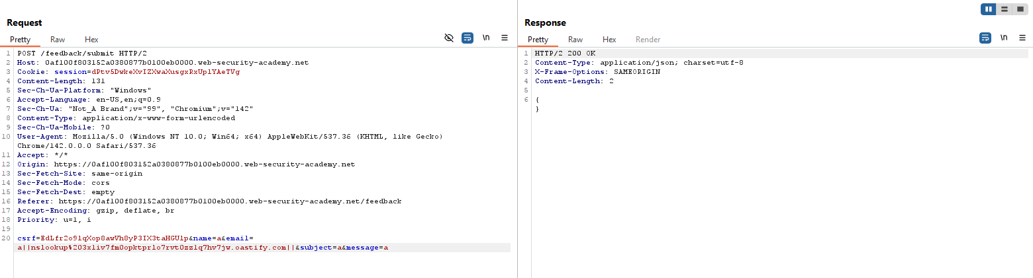

Blind OS command injection with out-of-band data exfiltration
